**Final implementation and tests**

**For Room Service on Demand project**

**Team 4 Members**

Vladimir Semenov

Vladimir Solovev

Valeria Iurinskaia

Marvin Lopez

**Table of contents**

Introduction

Test cases

1 Login test case

2 Create order test case

3 Logout test case

4 New stuff creation test case

5 Adding new payment option test case

6 Order activation test case

7 Order deactivation test case

8 Notifications test case

Test matrices

Test case options

Test case matrix

Test case 1 (TC1)

Test case 2 (TC2)

Test case 3 (TC3)

Test case 4 (TC4)

# Introduction

This document contains test cases and test matrices for room service on demand project. Test cases were created for each critical use case. Each test case was thoroughly tested to verify correctness of project implementation. All of the requirements were satisfied.

# 

# Test cases

## **1 Login test case**

|  |  |  |  |
| --- | --- | --- | --- |
| TEST CASE NAME: | Test the system login function | | |
| TEST ID: | TC-1 | | |
| TEST SUITE | Login | | |
| PRIORITY: | High | | |
| SETUP | User(User/Manager actor in this context no matter) with existing account ‘VladimirTest’ and password ‘Test123’ wants to login to the system | | |
| TEARDOWN: | User ‘VladimirTest’ is logout from the system | | |
| STEP | DESCRIPTION | RESULT | PROBLEM ID |
| TC-1-U1 | User go to login page | Passed |  |
| TC-1-U2 | User enters the required credentials and submits the form | Passed |  |
| TC-1-S3 | System checks the authentication data and login the User or reject the access | Passed |  |
| STATUS: | Passed | | |
| TESTER: | Vladimir | | |
| DATE COMPLETE | 28.11.19 | | |

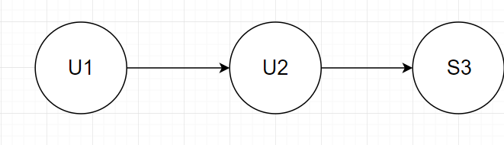

## 2 Create order test case

|  |  |  |  |
| --- | --- | --- | --- |
| TEST CASE NAME: | Test Place Order | | |
| TEST ID: | TC-2 | | |
| TEST SUITE | Create Order | | |
| PRIORITY: | High | | |
| SETUP | Order for Marvin Lopez apartment 2-111 containing cleaning service | | |
| TEARDOWN: | Remove the placed order | | |
| STEP | DESCRIPTION | RESULT | PROBLEM ID |
| TC-2-U1 | User enters the number of the apartment | Passed |  |
| TC-2-S2 | System display next field | Passed |  |
| TC-2-U3 | User enter description for cleaning | Passed |  |
| TC-2-S4 | System fulfill information about date and time | Passed |  |
| TC-2-S5 | System displays the complete information about the order | Passed |  |
| STATUS: | Passed | | |
| TESTER: | Vladimir | | |
| DATE COMPLETE | 28.11.19 | | |

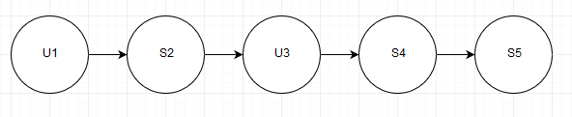

## 3 Logout test case

|  |  |  |  |
| --- | --- | --- | --- |
| TEST CASE NAME: | Test the system logout function | | |
| TEST ID: | TC-3 | | |
| TEST SUITE | Logout | | |
| PRIORITY: | High | | |
| SETUP | The logged in user ‘VladimirTest’ wants to logout from the system | | |
| TEARDOWN: | No TearDown required | | |
| STEP | DESCRIPTION | RESULT | PROBLEM ID |
| TC-3-U1 | User clicks logout button | Passed |  |
| TC-3-S2 | System performs logout | Passed |  |
| TC-3-S3 | System shows logout message | Passed |  |
| STATUS: | Passed | | |
| TESTER: | Vladimir | | |
| DATE COMPLETE | 28.11.19 | | |

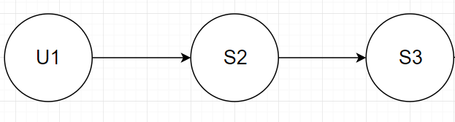

## 4 New stuff creation test case

|  |  |  |  |
| --- | --- | --- | --- |
| TEST CASE NAME: | Test the user account creation | | |
| TEST ID: | TC-4 | | |
| TEST SUITE | Create new stuff | | |
| PRIORITY: | High | | |
| SETUP | User wants to create new staff - VladimirTest | | |
| TEARDOWN: | Remove VladimirTest stuff | | |
| STEP | DESCRIPTION | RESULT | PROBLEM ID |
| TC-4-U1 | User selects the New Stuff | Passed |  |
| TC-4-S2 | System responds with the stuff creation form | Passed |  |
| TC-4-U3 | User fills all the required information and creates new stuff | Passed |  |
| TC-4-S4 | System responds that new stuff is created successfully | Passed |  |
| STATUS: | Passed | | |
| TESTER: | Vladimir | | |
| DATE COMPLETE | 28.11.19 | | |

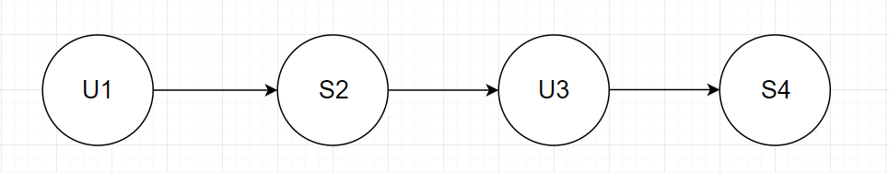

## 5 Adding new payment option test case

|  |  |  |  |
| --- | --- | --- | --- |
| TEST CASE NAME: | Test Adding Payment Options | | |
| TEST ID: | TC-5 | | |
| TEST SUITE | Add Payment Option | | |
| PRIORITY: | High | | |
| SETUP | Manager wants to add cash payment option | | |
| TEARDOWN: | Delete cash payment option | | |
| STEP | DESCRIPTION | RESULT | PROBLEM ID |
| TC-5-M1 | Manager select addition payment option | Passed |  |
| TC-5-S2 | System displays an input for payment option and a short description | Passed |  |
| TC-5-M3 | Manager fulfill the payment option and short description | Passed |  |
| TC-5-M4 | Manager input all remaining data | Passed |  |
| TC-5-S5 | System add the payment option data | Passed |  |
| STATUS: | Passed | | |
| TESTER: | Vladimir | | |
| DATE COMPLETE | 28.11.19 | | |

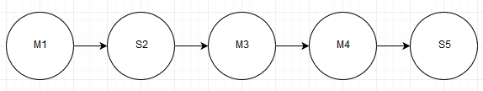

## 6 Order activation test case

|  |  |  |  |
| --- | --- | --- | --- |
| TEST CASE NAME: | Test order acceptance | | |
| TEST ID: | TC-6 | | |
| TEST SUITE | Accept Order | | |
| PRIORITY: | High | | |
| SETUP | Accept an order for Marvin lopez customer | | |
| TEARDOWN: | Remove the accepted order for Marvin Lopez | | |
| STEP | DESCRIPTION | RESULT | PROBLEM ID |
| TC-6-M1 | Manager select the details of Marvin Lopez order | Passed |  |
| TC-6-S2 | System responds by displaying Marvin Lopez order, indicating all the items ordered by Him | Passed |  |
| TC-6-M3 | Manager accept the order | Passed |  |
| TC-6-S4 | System indicates that the order has been accepted | Passed |  |
| STATUS: | Passed | | |
| TESTER: | Vladimir | | |
| DATE COMPLETE | 28.11.19 | | |

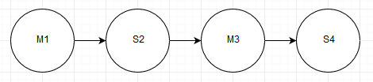

## 7 Order deactivation test case

|  |  |  |  |
| --- | --- | --- | --- |
| TEST CASE NAME: | Test order deactivation | | |
| TEST ID: | TC-7 | | |
| TEST SUITE | Deactivate Order | | |
| PRIORITY: | High | | |
| SETUP | Decline an order for Vladimir Semenov | | |
| TEARDOWN: | Remove the declined order for Vladimir Semenov | | |
| STEP | DESCRIPTION | RESULT | PROBLEM ID |
| TC-7-M1 | Manager select the details of Vladimir Semenov order | Passed |  |
| TC-7-S2 | System responds by displaying Vladimir Semenovorder, indicating all the items ordered by Him | Passed |  |
| TC-7-M3 | Manager select “decline order” option | Passed |  |
| TC-7-S4 | System display reason box | Passed |  |
| TC-7-M5 | Manager enter reason for declining and continue the process | Passed |  |
| TC-7-S6 | System displays a confirmation message | Passed |  |
| TC-7-M7 | Manager select “confirm” | Passed |  |
| TC-7-S8 | System indicates that the order has been declined | Passed |  |
| STATUS: | Passed | | |
| TESTER: | Vladimir | | |
| DATE COMPLETE | 28.11.19 | | |

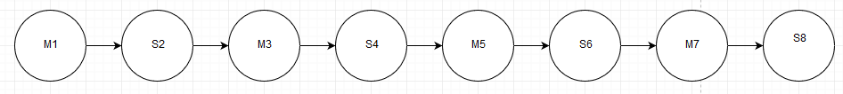

## 8 Notifications test case

|  |  |  |  |
| --- | --- | --- | --- |
| TEST CASE NAME: | Test the notification correctness | | |
| TEST ID: | TC-8 | | |
| TEST SUITE | Send notification | | |
| PRIORITY: | High | | |
| SETUP | Manager ‘Manager1’ performs any action with User ‘VladimirTest’ order ‘testOrder’ | | |
| TEARDOWN: | The order status must be returned to initial state | | |
| STEP | DESCRIPTION | RESULT | PROBLEM ID |
| TC-8-U1 | Manager opens ‘testOrder’ | Passed |  |
| TC-8-U2 | Manager performs any available action with the order (Edit/Activate/Approve/  Deactivate/ Delete/ Decline/Cancel). | Passed |  |
| TC-8-S3 | System creates and send email notification about performed action | Passed |  |
| TC-8-U4 | User receives the notification email | Passed |  |
| STATUS: | Passed | | |
| TESTER: | Vladimir | | |
| DATE COMPLETE | 28.11.19 | | |

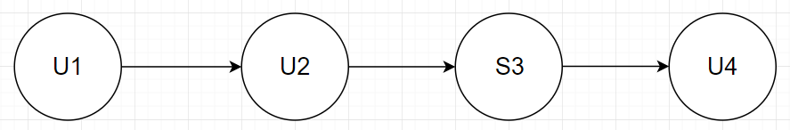

# Test matrices

**Login as customer:**

* **B1** Enter customer email
* **B2** Enter customer password

**Create new order:**

* **B3** Enter room number for new order
* **B4** Enter description
* **B5** Choose cleaning option
* **B6** Choose payment option
* **B7** Create order

**Logout**

* **B8** Press logout button

**Login as admin**

* **B9** Enter admin email
* **B10** Enter admin password

**Create new staff**

* **B11** Enter name
* **B12** Choose status

**Create new payment option**

* **B13** Enter name
* **B14** Choose status

**Activate order**

* **B15** Assign staff to the order
* **B16** Press activate button

**Deactivate order**

* **B17** Press deactivate button

## 

## Test case options

|  |  |  |  |  |  |
| --- | --- | --- | --- | --- | --- |
| Step | Variable or selection | Valid format (V) | Non-existent (NE) | Invalid format (INV) | Alternative (A) |
| B1 | Email | marvin@lopez.com | a@b.com | customer | - |
| B2 | Password | qwerty | password | - | - |
| B3 | Room number | 423 | 511 | avc | - |
| B4 | Description | Clean this | - | - | - |
| B5 | Cleaning option | Choose any staff option | - | Not chosen | - |
| B6 | Payment option | Any option from list | - | - | - |
| B7 | Create order | Pressed | Go back | - | - |
| B8 | Logout | Pressed | - | - | - |
| B9 | Admin email | admin@roomserviceinnopolis.com | admin@admin.com | admin | - |
| B10 | Admin password | admin1234 | password | - | - |
| B11 | Staff name | Anastasia | Obi-Wan | - | - |
| B12 | Staff status | Active | - | - | Inactive |
| B13 | Payment option name | Paypal | - | - | - |
| B14 | Payment option status | Active | - | - | Inactive |
| B15 | Assign staff to order | Choose any staff option | - | Not chosen | - |
| B16 | Activate order | Pressed Activate | - | - | - |
| B17 | Deactivate order | Pressed Deactivate | - | - | - |

## Test case matrix

|  |  |  |  |  |  |
| --- | --- | --- | --- | --- | --- |
| Step | Variable or selection | TC1 | TC2 | TC3 | TC4 |
| B1 | Email | V | NE | V | V |
| B2 | Password | V | V | NE | V |
| B3 | Room number | V | NE | V | INV |
| B4 | Description | V | V | V | V |
| B5 | Cleaning option | V | V | INV | INV |
| B6 | Payment option | V | V | V | V |
| B7 | Create order | V | NE | V | V |
| B8 | Logout | V | V | V | V |
| B9 | Admin email | V | V | V | V |
| B10 | Admin password | V | V | V | NE |
| B11 | Staff name | V | NE | V | V |
| B12 | Staff status | V | V | A | V |
| B13 | Payment option name | V | NE | V | V |
| B14 | Payment option status | V | V | V | A |
| B15 | Assign staff to order | V | INV | V | V |
| B16 | Activate order | V | V | V | V |
| B17 | Deactivate order | V | V | V | V |

## Test case 1 (TC1)

|  |  |  |  |  |
| --- | --- | --- | --- | --- |
| Step | Variable or selection | Value | Expected result | Obtained result |
| B1 | Email | marvin@lopez.com | - | - |
| B2 | Password | qwerty | Logged in, orders page | Logged in, orders page |
| B3 | Room number | 423 | - | - |
| B4 | Description | Clean this | - | - |
| B5 | Cleaning option | Choose any staff option | Option highlighted | Option highlighted |
| B6 | Payment option | Any option from list | Option chosen | Option chosen |
| B7 | Create order | Pressed | Orders page, order created | Orders page, order created |
| B8 | Logout | Pressed | Login page | Login page |
| B9 | Admin email | admin@roomserviceinnopolis.com | - | - |
| B10 | Admin password | admin | Admin dashboard page | Admin dashboard page |
| B11 | Staff name | Anastasia | - | - |
| B12 | Staff status | Active | Dashboard page, staff created | Dashboard page, staff created |
| B13 | Payment option name | Paypal | - | - |
| B14 | Payment option status | Active | Dashboard page, Payment option created | Dashboard page, Payment option created |
| B15 | Assign staff to order | Choose any staff option | Staff option highlighted | Staff option highlighted |
| B16 | Activate order | Pressed Activate | Dashboard page, order status activated | Dashboard page, order status activated |
| B17 | Deactivate order | Pressed Deactivate | Order status deactivated | Order status deactivated |

## Test case 2 (TC2)

|  |  |  |  |  |
| --- | --- | --- | --- | --- |
| Step | Variable or selection | Value | Expected result | Obtained result |
| B1 | Email | a@b.com | - | - |
| B2 | Password | qwerty | Email not exists error, relogin | Email not exists error, relogin |
| B3 | Room number | 511 | - | - |
| B4 | Description | Clean this | - | - |
| B5 | Cleaning option | Choose any staff option | Option highlighted | Option highlighted |
| B6 | Payment option | Any option from list | Option chosen | Option chosen |
| B7 | Create order | Go back | Orders page, order not created | Orders page, order not created |
| B8 | Logout | Pressed | Login page | Login page |
| B9 | Admin email | admin@roomserviceinnopolis.com | - | - |
| B10 | Admin password | admin1234 | Admin dashboard page | Admin dashboard page |
| B11 | Staff name | Obi-Wan | - | - |
| B12 | Staff status | Active | Dashboard page, staff created | Dashboard page, staff created |
| B13 | Payment option name | Paypal | - | - |
| B14 | Payment option status | Active | Dashboard page, Payment option created | Dashboard page, Payment option created |
| B15 | Assign staff to order | Not chosen | - | - |
| B16 | Activate order | Pressed Activate | Error, staff option required, order not activated | Error, staff option required, order not activated |
| B17 | Deactivate order | Pressed Deactivate | Button doesn't exist | Button doesn't exist |

## Test case 3 (TC3)

|  |  |  |  |  |
| --- | --- | --- | --- | --- |
| Step | Variable or selection | Value | Expected result | Obtained result |
| B1 | Email | marvin@lopez.com | - | - |
| B2 | Password | password | Wrong password, relogin | Wrong password, relogin |
| B3 | Room number | 423 | - | - |
| B4 | Description | Clean this | - | - |
| B5 | Cleaning option | Not chosen | Option required error, choose any | Option required error, choose any |
| B6 | Payment option | Any option from list | Option chosen | Option chosen |
| B7 | Create order | Pressed | Orders page, order created | Orders page, order created |
| B8 | Logout | Pressed | Login page | Login page |
| B9 | Admin email | admin@roomserviceinnopolis.com | - | - |
| B10 | Admin password | admin1234 | Admin dashboard page | Admin dashboard page |
| B11 | Staff name | Anastasia | - | - |
| B12 | Staff status | Inactive | Dashboard page, inactive staff created | Dashboard page, inactive staff created |
| B13 | Payment option name | Paypal | - | - |
| B14 | Payment option status | Active | Dashboard page, Payment option created | Dashboard page, Payment option created |
| B15 | Assign staff to order | Choose any staff option | Staff option highlighted, inactive staff option missing | Staff option highlighted, inactive staff option missing |
| B16 | Activate order | Pressed Activate | Dashboard page, order status activated | Dashboard page, order status activated |
| B17 | Deactivate order | Pressed Deactivate | Order status deactivated | Order status deactivated |

## Test case 4 (TC4)

|  |  |  |  |  |
| --- | --- | --- | --- | --- |
| Step | Variable or selection | Value | Expected result | Obtained result |
| B1 | Email | marvin@lopez.com | - | - |
| B2 | Password | qwerty | Logged in, orders page | Logged in, orders page |
| B3 | Room number | 511 | - | - |
| B4 | Description | Clean this | - | - |
| B5 | Cleaning option | Not chosen | Option required error, choose any | Option required error, choose any |
| B6 | Payment option | Any option from list | Option chosen | Option chosen |
| B7 | Create order | Pressed | Orders page, order created | Orders page, order created |
| B8 | Logout | Pressed | Login page | Login page |
| B9 | Admin email | admin@roomserviceinnopolis.com | - | - |
| B10 | Admin password | password | Wrong password error, relogin | Wrong password error, relogin |
| B11 | Staff name | Anastasia | - | - |
| B12 | Staff status | Active | Dashboard page, staff created | Dashboard page, staff created |
| B13 | Payment option name | Paypal | - | - |
| B14 | Payment option status | Inactive | Dashboard page, Inactive payment option created | Dashboard page, Inactive payment option created |
| B15 | Assign staff to order | Choose any staff option | Staff option highlighted | Staff option highlighted |
| B16 | Activate order | Pressed Activate | Dashboard page, order status activated | Dashboard page, order status activated |
| B17 | Deactivate order | Pressed Deactivate | Order status deactivated | Order status deactivated |